Summer/Fall 2019 Registration Calendar for Career & College Promise Students
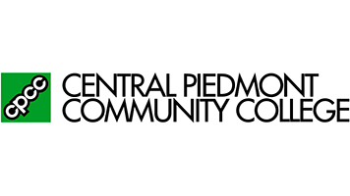
First day of Open Enrollment: April 29, 2019
First day of Summer 2019 semester: May 20, 2019
First day of Fall 2019 semester: August 15, 2019

***An email is sent to the student’s CPCC email address once processed indicating when cleared to register for the indicated participating 2019 semester. Please remember that students must submit permission for each semester. See the processing dates below.
Students submitted between March 1st through April 12 | Will be able to register by April 29, 2019 (First day of enrollment available for all new and returning students)
Students submitted between April 13 through April 19 | Will be able to register by May 6, 2019
Students submitted between April 20 through April 26  Students submitted after April 27 will be processed in the order received. Please allow 5 business day for completion. | Will be able to register by May 13, 2019  Processing for Summer 2019 will close on May 13. Student fees for the Summer semester are due no later than May 17, 2019 to prevent courses from automatically being dropped.
CPCC Career and College Promise Important Dates

