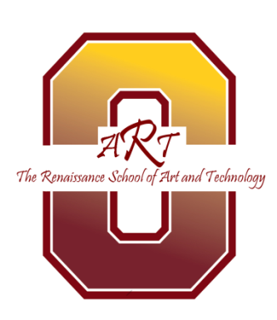

The Renaissance School of Arts and Technology
AOIT Design Team Meeting
March 10, 2014
Agenda
Location: Room 242
Call to order 2:30 PM
AOIT Director’s report 2:45 PM -3:00 PM
- Updates on AOIT status- Data Center
- AOIT recruitment for 2014-2015 –
- Curriculum updates for 2014-2015
- New about the conversion

NAF Academy Assessment review Feb 6th 3:00 PM- 3:15 PM
Old Business
Please think about a key note speaker for the senior banquet
New Business 3:15 PM – 3:30 PM

- Establish Committees
- Next steps
Meeting Adjourned

Committee structure
Committee name | Charter | Members (chair)
Membership/  recruitment | Establish a recruiting plan in cooperation with the Academy Director/Manager.  Organize a Speakers Bureau to have people available for school recruitment visits, parent conferences, and recruitment assemblies.  Assist in the development of recruitment material (flyers, slide shows, videos, brochures or other communications materials).
Internship | Assist in locating and evaluating potential internship positions.  Review internship experiences annually to ensure quality experiences for the students.  Assist in the development of a pre-internship orientation program for students and internship providers.  Develop a student career shadowing/mentor program.
PR/Marketing | Develop an annual Academy public relations plan.  Assist in the preparation and the distribution of media materials. (Companies may be willing to provide in-kind contributions to this effort.)  Develop a local media list including the names, addresses and phone numbers of print and electronic journalists, business associations, industry related organizations, etc.  Invite members of the media to Academy activities.  Assist in the promotion of special Academy activities (ie: graduation, awards ceremonies, student competitions, etc.).

